**Lab report no 9**



**Fall 2022**

# Control System Lab

**Submitted By**

**Name Registration No**

# Muhammad Ali 19pwcse1801

Section: **A**

**Date**: 15,01,23

**Submitted to: Dr Muniba Ashfaq**

Department of Computer Systems Engineering

University of Engineering and Technology, Peshawar

**Objectives: -**

* To understand negative feedback system both in Matlab and Simulink
* To learn how to computer steady state error and to design controller for it.

**Task no 1: -**

**Design negative feedback system both in Matlab and Simulink and control the step response of the given system. Performance requirement of close loop system is that the steady state error = 0.**

**Given system:**

**G(s) = 1/ s^2 + 3s + 1**

**Matlab Code:**

clc

close all

clear all

num = [1];

denum = [1 3 1];

G = tf(num,denum);

Feedback_sys = feedback(G,1);

figure;

step(Feedback_sys)

a = findobj(gca,'type','line')

for i = 1:length(a)

set(a(i),'markersize',16) %change marker size

set(a(i), 'linewidth',3) %change linewidth

end

title('Negative Feedback System');

xlabel('time(seconds)');

ylabel('Amplitude');

hold on;

kp = 1;

kd = 1;

ki = 2;

PID_system = pid(kp,ki,kd);

controlled_feedback_system = feedback(G*PID_system,1);

figure;

step(controlled_feedback_system)

a = findobj(gca,'type','line')

for i = 1:length(a)

set(a(i),'markersize',16) %change marker size

set(a(i), 'linewidth',3) %change linewidth

end

title('Controlled Feedback System');

xlabel('time(seconds)');

ylabel('Amplitude');

**Output:**

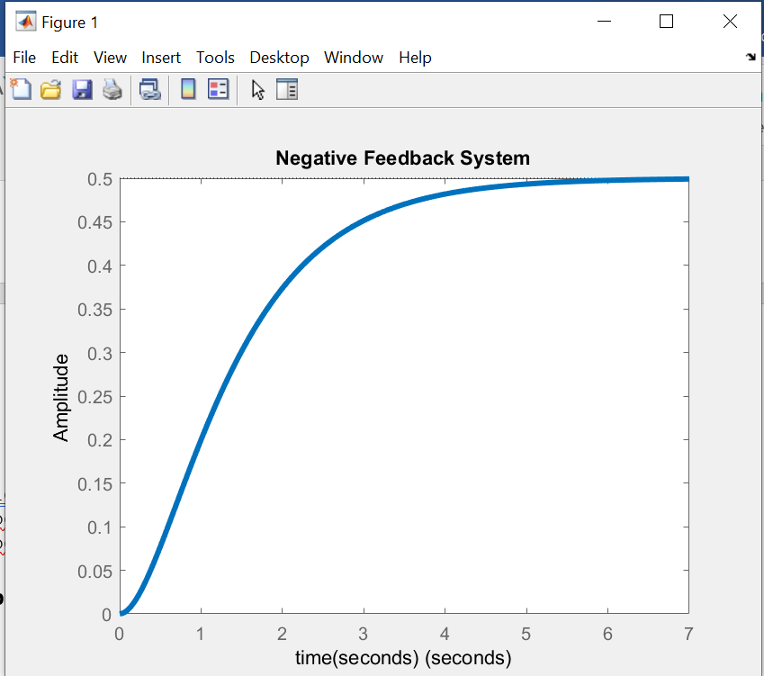

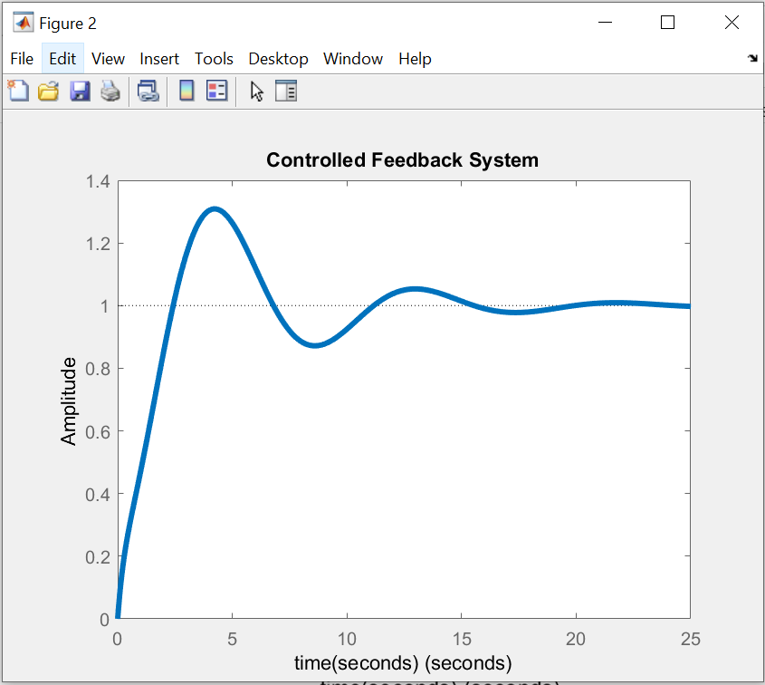

**Combined Output:**

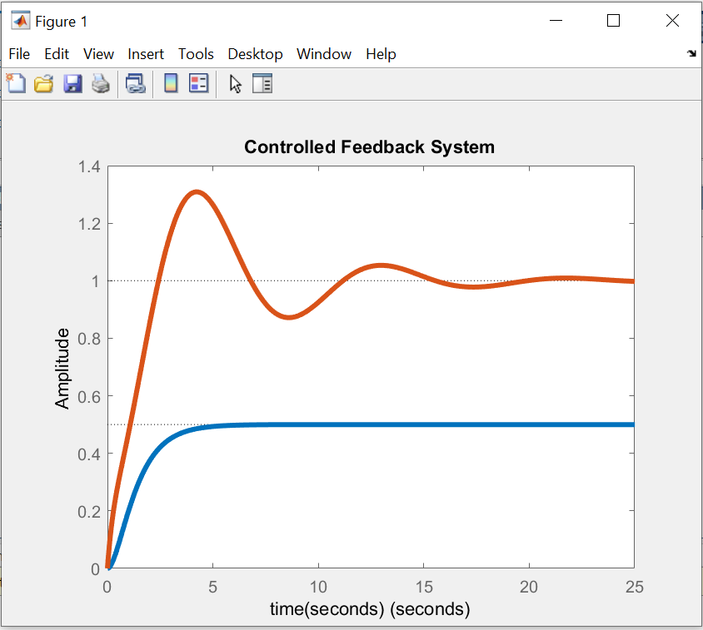

**Steady State Error: -**

**Before Controller:-**

Steady State Error = input – output

Steady State Error = 1 – 0.5

Steady State Error = 0.5

**After Controller: -**

Steady State Error = input – output

Steady State Error = 1 - 1

Steady State Error = 0.

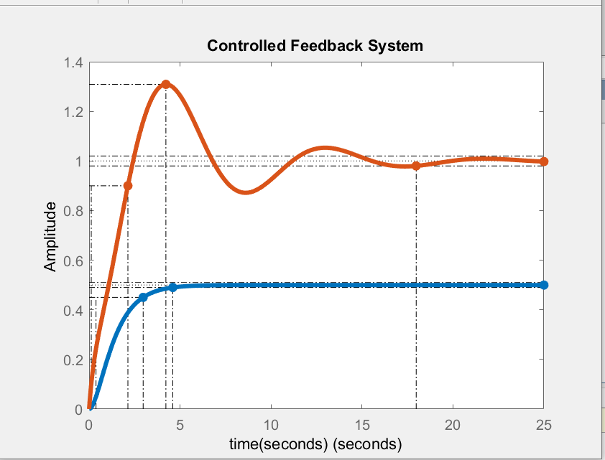

**Changing values of Kp,kd,ki effects certain characteristics of system response.**

**For example increasing the value of kp, reduces rise time and settling time as shown in the figure below:**

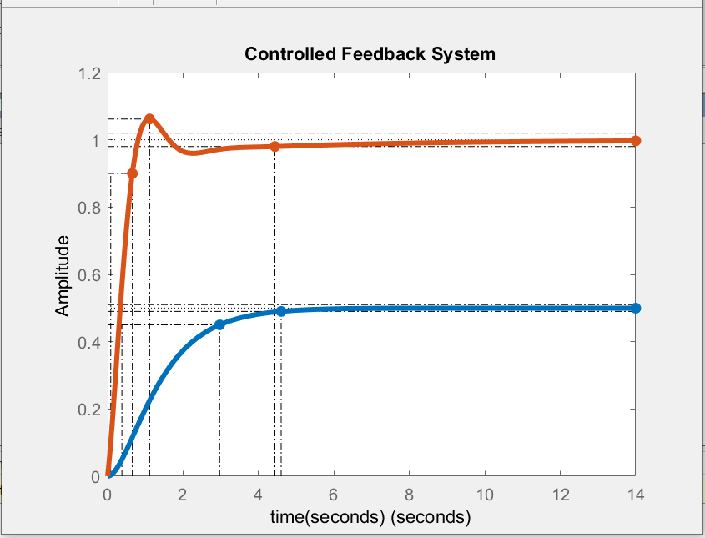

**When the value of kp was 1 the settling time was 18s and when it was incremented to 10 the settling time was 4.43s.**

**Simulink:**

**Without Controller: -**

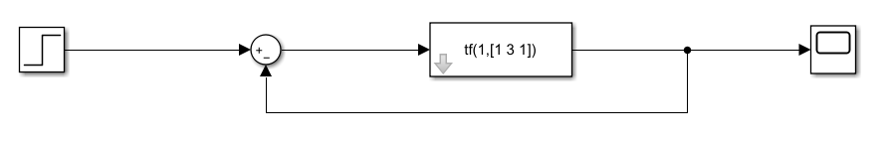

**Output:**

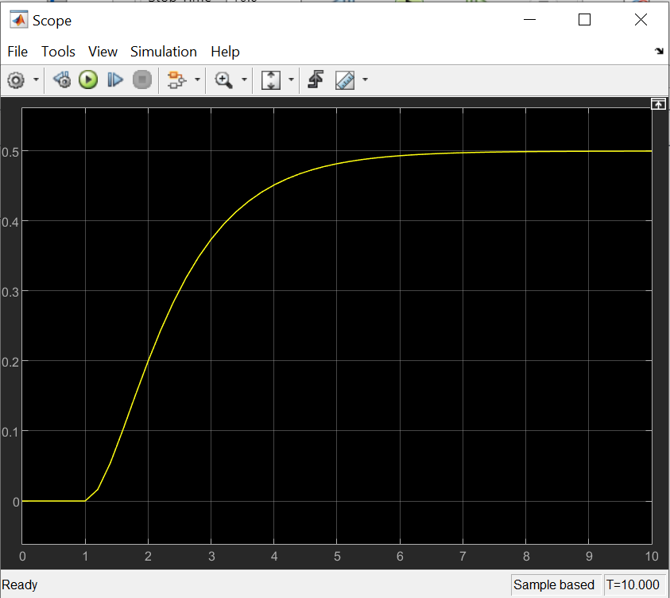

**As it can be seen the output is same as obtained above through matlab code and have a steady state error of 0.5.**

**After controller: -**

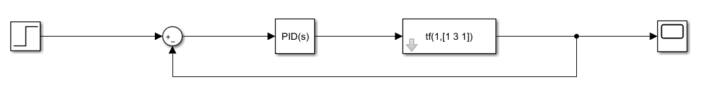

**Output;**

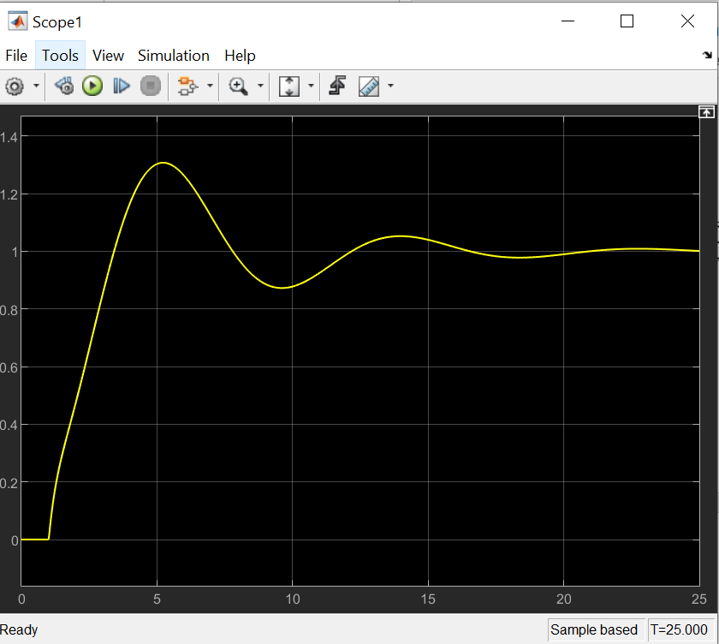

**As it can be seen the output is same as obtained above through matlab code and have a steady state error of 0.**

**PID Tuning: -**

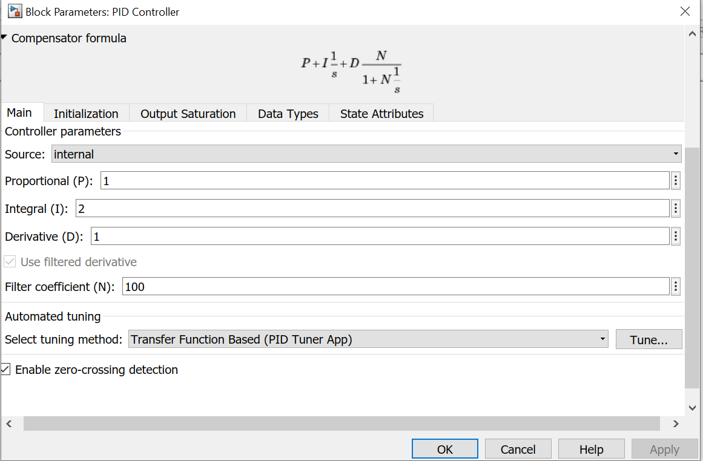

**Response after Tuning:**

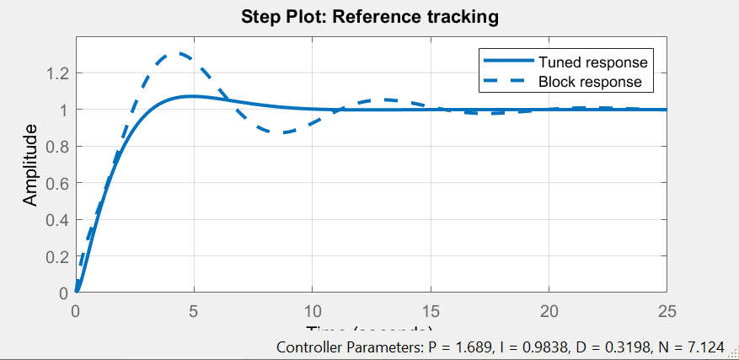

**Tuned Response of Scope:**

